

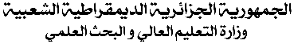

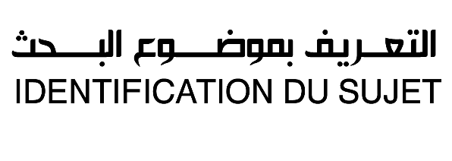

(Formulaire CERIST)

Faculté :………………………………………………………….………………………..........................................................................................................................................………..الكلية:......
Département :………………………………………………………….………………………..........................................................................................................................………..القسم:......
N° de référence :الرقم المرجعي:.....................................................................................................................................................................................................................
Année d’inscription :سنة التسجيل:...........................................................................................................................................................................................................
Etudiant (Nom / Prénom) :……………………………....................................................................................................................…………الطالب(الاسم/اللقب):.........
Encadreur (Nom / Prénom) :………………………………….................................................................................................................…...…… : المشرف(الاسم/اللقب)
Spécialité :………………………………………………………..…......................................................................................................................…..................................…التخصص:........
Option : ………………………………………………………………......……الشعبـة :................................................................................................................................................................
Nature de la thèse : طبيعة الأطروحة:
Doctorat دكتوراه
Titre de la thèse:……………….............................................................................................................................………عنوان الأطروحة:...............................................
Mots clés (Au moins 04 ): ……………..………………………..…………….....……..........................................................................…الكلمات المفتاحية (على الأقل 04):
Résumé : …………………………………………………………………………………………………………………………………………………………………………………..................................…الملخص.....
………………………………………………………………………………………………………………………………………………………………………………………………………………………….....................................
………………………………………………………………………………………………...............................................................................................................................................................................
………………………………………………………………………………………………...............................................................................................................................................................................
………………………………………………………………………………………………...............................................................................................................................................................................
………………………………………………………………………………………………...............................................................................................................................................................................
………………………………………………………………………………………………...............................................................................................................................................................................
………………………………………………………………………………………………...............................................................................................................................................................................
………………………………………………………………………………………………………………………………………………………………………………………………………………………………………………………….
………………………………………………………………………………………………………………………………………………………………………………………………………………………………………………………….
………………………………………………………………………………………………………………………………………………………………………………………………………………………………………………………….

Cadre réservé au CERIST
N° du formulaire:
Date de réception:
Date de validation :

